Purpose
The purpose of this document is to assist the Subrecipient in demonstrating the location of the property in relation to FEMA established Special Hazard Flood Areas and Floodways.
Finding the Latitude and Longitude of My Property
Visit https://www.latlong.net/convert-address-to-lat-long.html and enter the address in question.
The website will generate a latitude (“lat”) and longitude (“lon”) and these coordinates should be used to view the property via the Flood Partners Website below.
Viewing My Property in Flood Maps
Step 1
Visit https://www.floodpartners.com/ to enter the latitude and longitude of the property in question.
Example: Enter the Lat and Lon provided by the latlong.net service separating the lat and lon with a (,).
30.70530,-97.741690
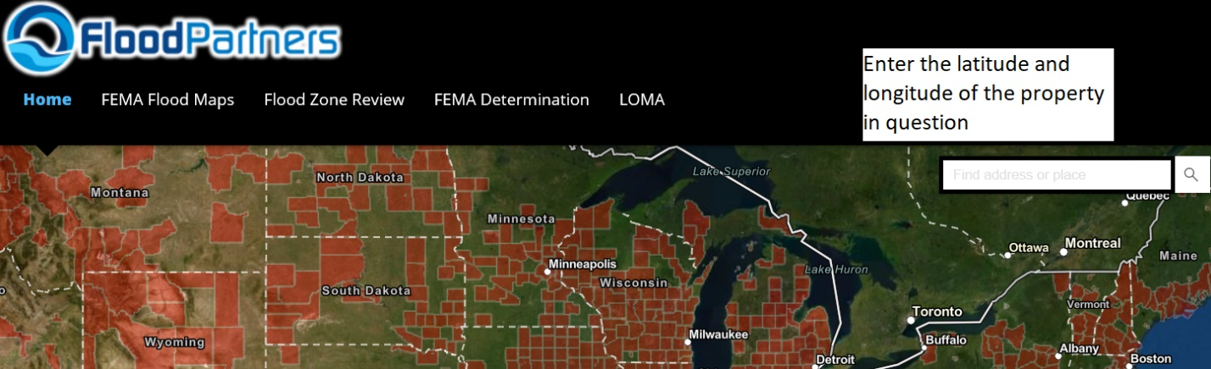
Step 2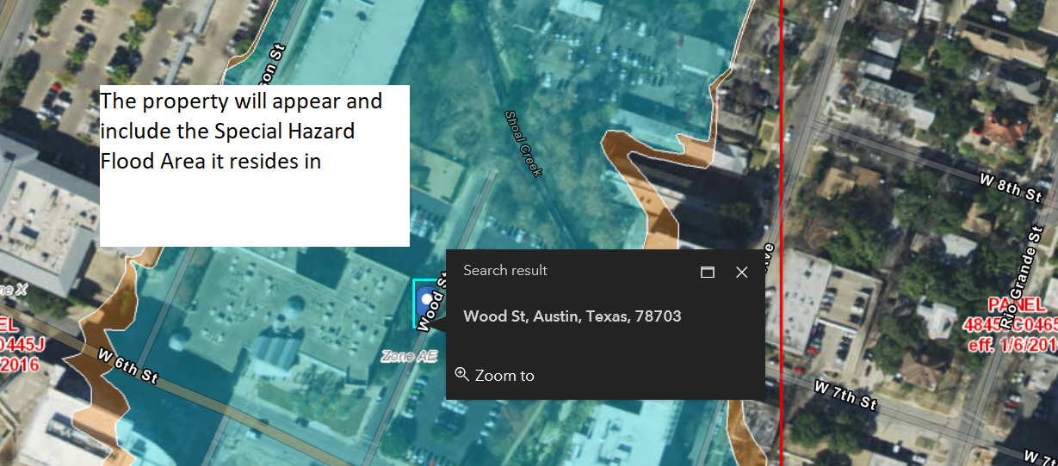

Step 3
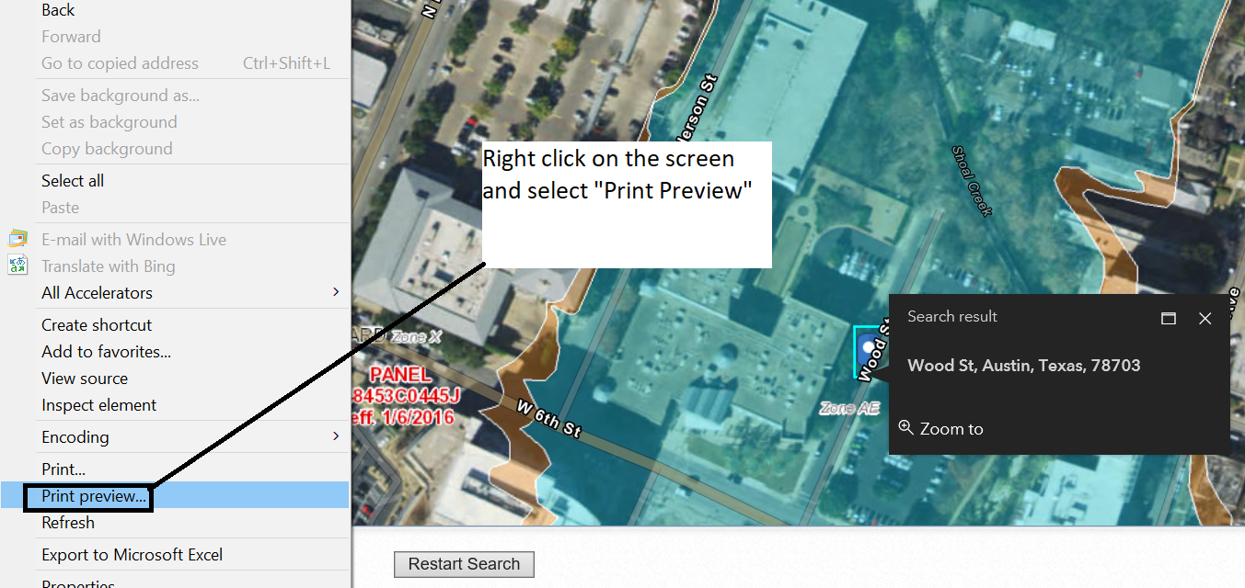

Step 4
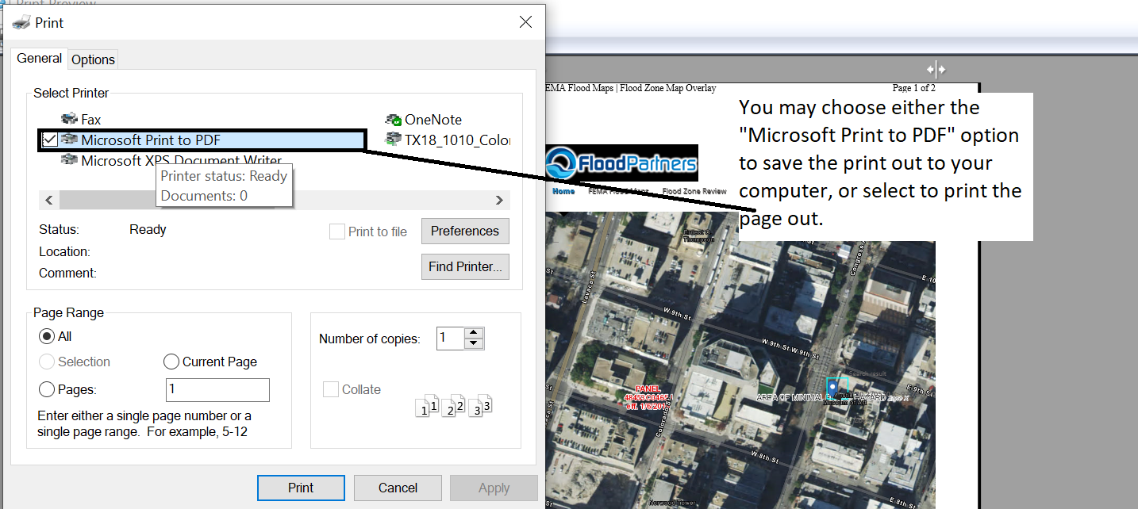
Step 5
If choosing the “Microsoft Print to PDF” option, the computer will prompt the applicant to save to a folder on the computer. If electing to print the page, the applicant can either submit the hard copy or scan the print out to another storage device.

Disclaimer: The Texas General Land Office has made every effort to ensure the information contained on this form is accurate and in compliance with the most up-to-date CDBG-DR and/or CDBG-MIT federal rules and regulations, as applicable. It should be noted that the Texas General Land Office assumes no liability or responsibility for any error or omission on this form that may result from the interim period between the publication of amended and/or revised federal rules and regulations and the Texas General Land Office's standard review and update schedule.

